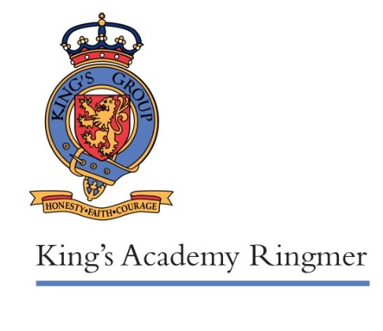

12 September 2018

Dear Parents and Carers

We have a vacancy for a parent governor at King’s Academy Ringmer.

The aim of school governance is to help secure the best possible education for children in our schools. Governors take part in deciding what school priorities are, and help support school leadership and staff in reaching their goals. In order to do this, training is offered on the different topics around governance. Governors have many interesting opportunities to discuss and make decisions, and to meet other governors from other areas in order to find out what current best practice is. It can be very satisfying as a governor to know that you are helping make things work well, and also to discover things that could make our schools better.

Good governance draws on many qualities, but the most consistently useful ones are openness, ability to balance different views in coming to decisions, and readiness to learn.

The role involves:
6 evening meetings a year
2-4 monitoring visits across the schools a year, plus a related short written report
At least two training sessions a year
1-2 attendances at school events in order to meet parents
Various other ad hoc working groups as required.

If you are interested in such a role, please read the attached Qualification Criteria to satisfy yourself that you comply with the legal requirements for being a governor, and fill in the attached form to express your interest in applying. Please return your form to Amanda French by Friday 28th September 2018.

I am always willing to chat more about the role of governors, if you would like to know more before you apply. Please email denise.kong@kingsacademies.uk

If there are more than two interested parties, we will arrange for a ballot to take place, which is where we will use the statement in your nomination form.

We are looking forward to receiving nominations.

Yours faithfully

Denise Kong
Chair of Governors

