Name

Key to Five

Unit 1: HCF/LCM and Primes

The Pixl Ladder to Success

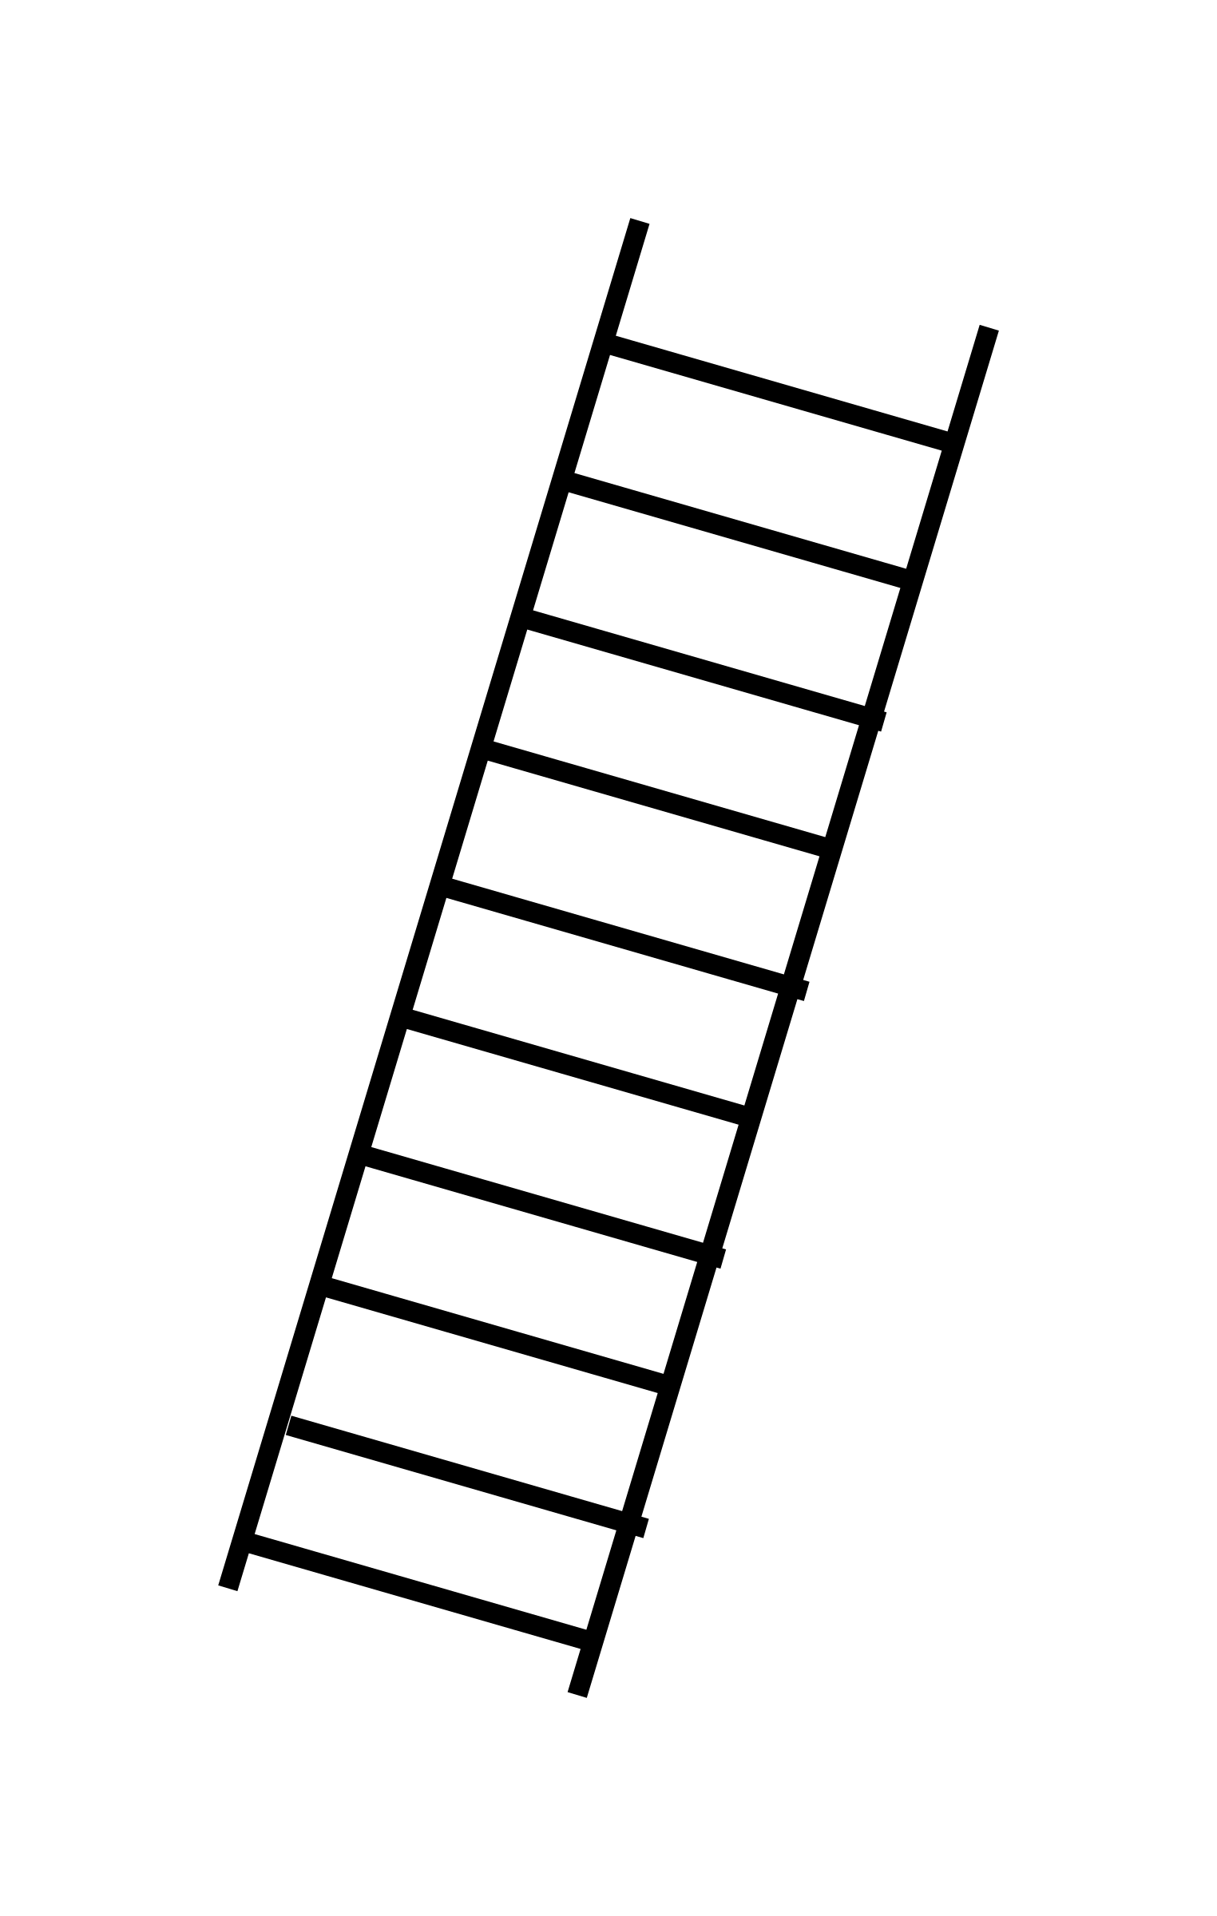

- Questions in context
- BIDMAS
- Use Venn diagrams to find the HCF/ LCM
- Express numbers as product of primes
- HCF/LCM of small numbers
- Explain your answers
- Listing factors
- Listing multiples

© The PiXL Club Limited 2017 - This resource is strictly for the use of member schools for as long as they remain members of The PiXL Club. It may not be copied, sold nor transferred to a third party or used by the school after membership ceases. Until such time it may be freely used within the member school. All opinions and contributions are those of the authors. The contents of this resource are not connected with nor endorsed by any other company, organisation or institution.

Section A

Question 1
Write 200 as a product of its prime factors

(2)

Question 2

(a) Express 120 as a product of its prime factors.

(2)
....................................................................................................

Question 3

Use this factor tree to write 54 as a product of its prime factors.
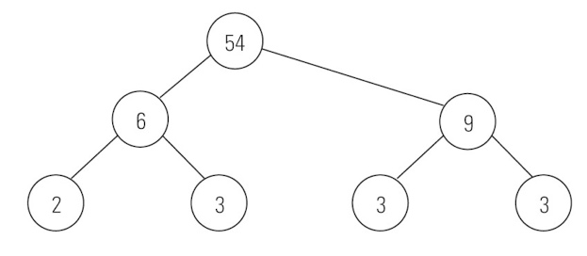

....................................................................................................
Question 4

Write each of the following numbers as the product of its prime factors.

a 24 ...................................................................... b 40 ......................................................................

c 50 ...................................................................... d 72 ......................................................................

(Total 4 marks)

Question 5
Express 420 as the product of its prime factors.

....................................
[2]

Question 6
As a product of prime factors,
24 = 2 × 2 × 2 × 3.
Write 40 as a product of prime factors.

.......................................
[2]

Question 7
Write 48 as a product of primes, give your answer in index form

(2 marks)

Section B

Question 8

- Find the highest common factor (HCF) of 30 and 45

(2)
- Find the lowest common multiple (LCM) of 30 and 45

(2)
Question 9
Using any method you like find the HCF of 44 and 77

(3)

Question 10

Find the highest common factor (HCF) of 90 and 120

(1)
...........................................................
Question 11

(a) Work out the highest common factor (HCF) of
16 and 20

(1)
...........................................................

(b) Work out the Lowest common multiple (LCM) of

16 and 20

(1)
...........................................................

)

Question 12
Find the lowest common multiple (LCM) of 25 and 30.

..........................................
[2]

Question 13

(i) Work out the highest common factor (HCF) of 24 and 40.

.......................................
[2]
(ii) Work out the lowest common multiple (LCM) of 24 and 40.

.......................................
[2]

Section C

Question 14

Work out.
(a) 6 – 2 × 5
..................................
[1]
(b) (4 + 2)2
..................................
[1]

(c) 3 × 52 + 4 × 5

.................................
[2]

Question 15
(a) Anna and Cath work out this sum.
4 + 2 × 4 =
Anna says the answer is 24.
Cath says the answer is 12.
Who is correct? Give a reason.
Write Anna or Cath on the first space.
......................................... because ..............................................................................
.....................................................................................................................................
[1]

(b) Work out.
(14 – 6) × 22

......................................
[2]

Question 16
Insert brackets in each of the following calculations so that they are correct.
3+ 5 × –4 = –32
2 × 5 + –42 = 2
2 × 5 + –42 = 36
[3]

Question 17

Work out the value of (4 + 2) × 2 + 3

…………………
(1)

Question 18

Calculate;

- $4^{2}+3 ×2$

- $14+2 ×6$

- $\frac{3^{2}+8}{2}$

(Total 3 marks)

Question 19

Work out

a 37 – (6 x 3)

b (7 + 2) - (16 – 9)
.
c 7 x 5 + 3 x 8

d 45 ÷ (8 – 3)

(Total 4 marks)

Question 20

Crackers are sold in boxes of 18.
Cheese slices are sold in packs of 14.
Sam wishes to buy the same number of crackers and cheese slices. What is the minimum number of boxes of crackers and packs of cheese slices Sam should buy?

(3 marks)

