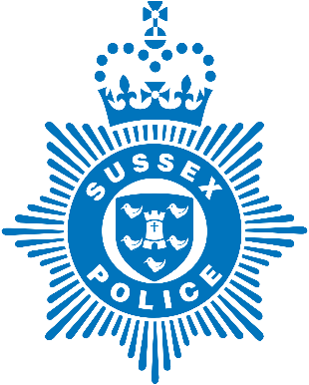

Police Community Support Officer drop in session
Saturday 4th December in Ringmer precinct between 10 -12 am

Come along and meet your local Police Community Support Officers Collins and Scott for a drop in session to talk about local issues, and raise awareness of current scams affecting local residents.
If you have been the victim of fraud or a scam, please report www.sussex.police.uk 101 - or 999 in an emergency/where you feel threatened.
Anyone can fall victim to fraud. If you think you’ve been a victim of fraud, contact your bank immediately and report it to Action Fraud online at actionfraud.police.uk or by calling 0300 123 2040.
- Stop: take five, and take a moment to stop and think before parting with your money or information could keep you safe – speak to a family member first.
- Challenge: could it be fake? It’s okay to reject, refuse or ignore any requests. Only criminals will try to rush or panic you.
- Protect: if you think you’ve been a victim of fraud, contact your bank immediately and report it to Action Fraud online at actionfraud.police.uk or by calling 0300 123 2040.


