
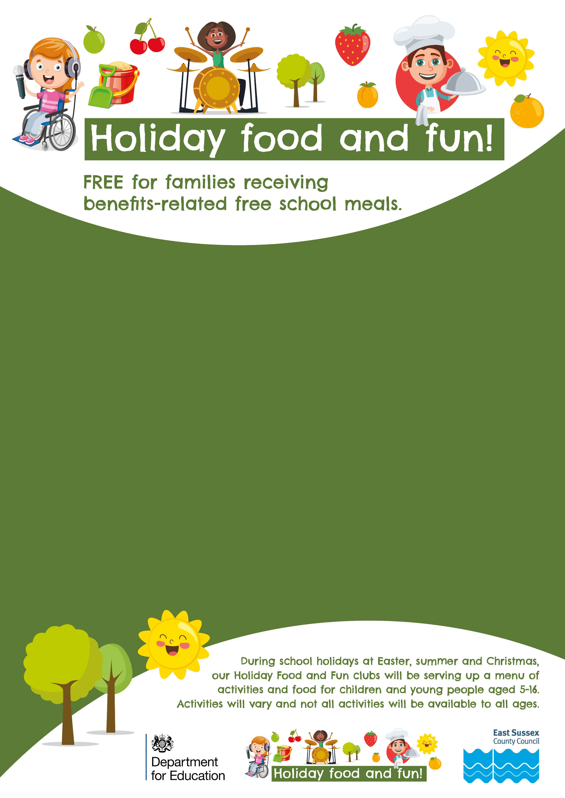
Scan the QR code or visit the “Holiday Food and Fun in East Sussex” website for details of activities in your area and to book a place.

Think there’s no such thing as a free lunch? WRONG!!

There are exciting holiday activities, including a free lunch, for children in receipt of benefit-related free school meals taking place over the school holidays.

From circus skills to animation workshops, from drama to team sports, from arts and crafts to forest schools, there is something for everyone.

